🧘 Summary of Research on Yoga's Impact on PTSD
Research, primarily through Randomized Controlled Trials (RCTs) and meta-analyses, strongly suggests that yoga practice is a promising and effective complementary intervention for reducing symptoms of Post-Traumatic Stress Disorder (PTSD).
Key Findings and Mechanisms
- Symptom Reduction: Multiple studies, particularly those using Trauma-Sensitive Yoga (TSY), have shown that yoga interventions lead to statistically significant improvements in self-reported PTSD symptom severity, often comparable to well-established psychotherapeutic and pharmacological treatments. Specific areas of improvement include hyperarousal, intrusive thoughts, and re-experiencing symptoms.
- Comorbid Conditions: Yoga interventions have also been consistently shown to significantly reduce co-occurring depressive symptoms in individuals with PTSD.
- Mechanism of Action: The benefit of yoga is believed to stem from its ability to address the somatic (body-based) and physiological dysregulation that is central to PTSD. Key mechanisms include:
  - Increasing Interoceptive Awareness: Yoga (asanas and focused breathing) helps trauma survivors to safely re-engage with and tolerate physical and sensory experiences associated with fear and helplessness, thus countering the common trauma response of avoidance.
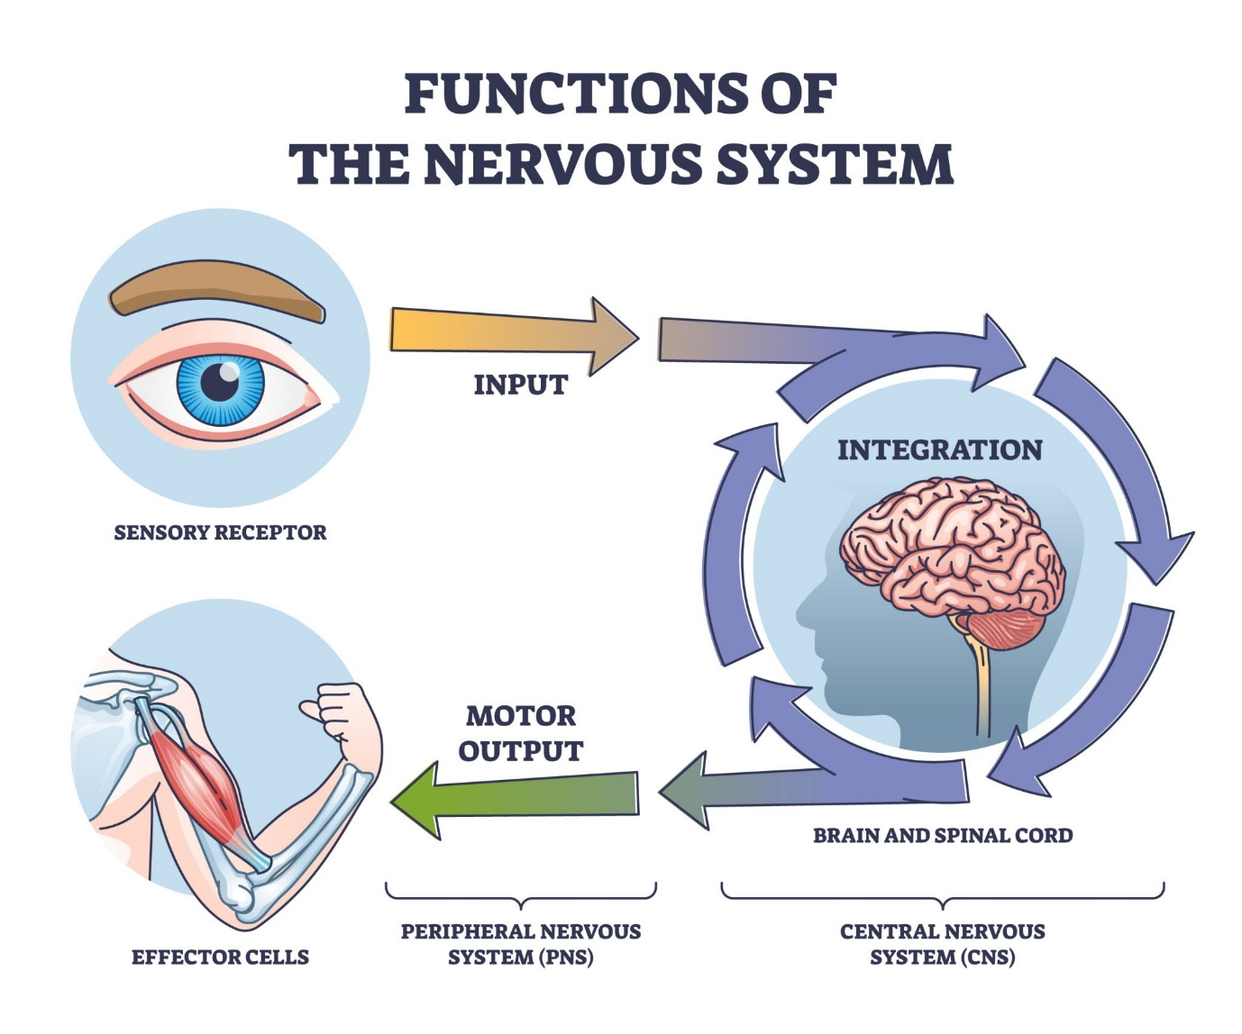
Getty Images
Explore
* **Autonomic Nervous System (ANS) Regulation:** Breathing techniques (Pranayama) and relaxation are hypothesized to shift the body's stress response from the **sympathetic nervous system** (fight-or-flight) towards the **parasympathetic nervous system** (rest-and-digest), potentially reducing amygdala hyperactivation and elevated cortisol levels.
* **Emotional Regulation:** The mindfulness and non-judgmental awareness cultivated in yoga increase a person's ability to tolerate and manage intense emotions, improving psychological flexibility and reducing reliance on dysfunctional coping mechanisms like expressive suppression.
- Trauma-Sensitive Approach: A critical theme in the successful research is the use of Trauma-Sensitive Yoga (TSY), which emphasizes invitational language, physical space, and choice to help survivors feel safe and empowered, often focusing less on the aesthetic perfection of a pose and more on the internal experience.

📚 PubMed References on Yoga and PTSD
The following is a list of published articles available on PubMed that represent key research in this area, including randomized controlled trials and systematic reviews:
Key Randomized Controlled Trials (RCTs)
- van der Kolk, B. A., Stone, L., West, J., Rhodes, A., Emerson, D., Suvak, M. K., & Spinazzola, J. (2014). Yoga as an adjunctive treatment for posttraumatic stress disorder: a randomized controlled trial. The Journal of clinical psychiatry, 75(8), e1044–e1051. (PMID: 25004196)
- Price, M., Spinazzola, J., Musicaro, R., Turner, J., & Suvak, M. (2018). Effectiveness of an Extended Yoga Treatment for Women with Chronic Posttraumatic Stress Disorder. The Journal of Alternative and Complementary Medicine, 24(5), 452–459. (PMCID: PMC5393408)
- Mitchell, K. S., Dick, A. M., Gerber, M. R., Pine, R., Hong, S., & Mills, S. (2014). A pilot study of a Kundalini Yoga intervention for women with posttraumatic stress disorder. Journal of Traumatic Stress, 27(5), 614–618. (PMCID: PMC4558444)
- Desai, N. R., & Mehta, R. (2025). A Yoga Intervention for Posttraumatic Stress: A Preliminary Randomized Control Trial. Evidence-based complementary and alternative medicine : eCAM, 2025, 2470719. (PMID: 281779476, check publication year)
Systematic Reviews and Meta-Analyses
- Cramer, H., Anheyer, D., Saha, F. J., Dobos, G., & Michalsen, A. (2018). Yoga for posttraumatic stress disorder – a systematic review and meta-analysis. Complementary therapies in medicine, 37, 118–125. (PMCID: PMC5863799)
- Laplaud, N., Perrochon, A., Gallou-Guyot, M., Moens, M., Goudman, L., David, R., Rigoard, P., & Billot, M. (2023). Management of post-traumatic stress disorder symptoms by yoga: an overview. BMC psychiatry, 23(1), 522. (PMID: 37480017)
- Zaccari, B., Nejadghaderi, S. A., Salimi, A., & Kolahdozi, S. (2025). Efficacy of yoga for post-traumatic stress disorder: A systematic review and meta-analysis of randomized controlled trials. Psychiatry Research, 337, 115984. (PMCID: PMC12100614, check publication year)

